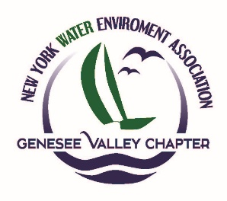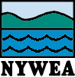

**Genesee Valley Chapter**

**New York Water Environment Association, Inc.**

#### *GVC April Meeting*

Friday, April 11th, 2025

Mendon Community Center

67 N Main St, Honeoye Falls, NY 14472

8:00 – 8:30 Registration/Coffee, Juice, and Danish

8:30 – 8:45 Welcome – Matt Higgins (LaBella) / Matt McKenna (MRB), Co-Chair of GVC NYWEA

8:45 – 9:45 **TBD**

9:45 – 10:45 **Electrical 101 for Wastewater Professionals**

10:45 – 11:00 Break

11:00 – 12:00 **Genesis and Development of a Regional Wastewater Treatment Solution for Western Wayne County through Construction**

12:00 – 1:00 **Case Study: Wellsville Wastewater Treatment Facility Project – Prioritizing Improvements During Cost Escalation Challenges**

1:00 – 2:00 Lunch!

**Registration Form**

**Cost:**  NYWEA Members $50

Non-Members $135*

Student Members Complimentary

Students (incl. 1 yr. membership & publications) $50*

# Name Organization Member ID #

_____________________________________________________________________________

**Sponsorship Opportunities\*\***

Meeting Sponsor $100

*The NYWEA is a member organization whose sole purpose is the support of its members. In order to increase our membership and strengthen our foundation, we have changed our chapter meeting registration fee structure. In order to ensure that all of our meeting attendees are able to enjoy the benefits of membership in the NYWEA, the $135.00 ($50.00 for students) registration for this meeting will include an affiliate membership in the NYWEA. At the time of registration, you will

be handed a membership application and upon filling that out, your membership will be formal. Member renewal costs will be based on the Dues Amounts shown on the Membership form plus $15 to cover the food cost to attend this event. GVC NYWEA will submit and process the membership form as a service to the member.

** Sponsorship will include acknowledgement of meeting sponsorship, display of advertising PowerPoint slide of your company prior to be commencement of each of the speaker presentations. The sponsor will need to contact Mike Hershelman with digital copy of company logo for inclusion in PowerPoint slide displays.

**Please respond by December 1, 2024, with appropriate payment to:**

HUNT Engineers

Attn: Nick Bayer

4 Commercial Street, Suite 300, Rochester, NY 14614

Phone: 585.337.4011

E-mail: bayern@hunt-eas.com

**Note: Make check payable to Genesee Valley Chapter NYWEA Inc. or pay with PayPal.**

**3 Operator Renewal Credits and Professional Development Hours (PDHs) have been applied for.**